# Molecular Redox Reactions

The electron loss and gain is easy to see in a reaction in which ions are formed. However, in many reactions, no such electron transfer occurs. In a molecular compound, electrons are shared between atoms in a type of bond called a covalent bond. Yet it is still common for reactions involving molecular compounds to still be classified as redox reactions.

When hydrogen gas is reacted with oxygen gas, water is formed as the product.

2H2(g)+O2(g)→2H2O(l)

In the individual hydrogen molecules, a pair of bonding electrons is shared equally between the hydrogen atoms (a nonpolar covalent bond). Likewise, the bonding electrons in the oxygen molecule are also shared equally between the two oxygen atoms. However, when the atoms are rearranged to form the water molecule, the electron **sharing is no longer equal**. In each hydrogen-oxygen bond in the water molecule, the bonding electrons are more attracted to the oxygen atom than they are to the hydrogen atom. We know this will occur because oxygen has a higher electronegativity than hydrogen. In this reaction two non-polar molecules produce a polar molecule.

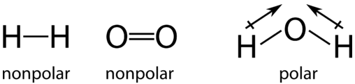

During this reaction, electrons are shifted away from each hydrogen atom and towards the oxygen atom. **The hydrogen is oxidized because it undergoes a partial loss of electrons.** Even though the loss is not complete enough to form ions, the hydrogen atoms in water have less electron density near them than they did in the H2 molecule. The oxygen is reduced because it undergoes a partial gain of electrons. The oxygen atom in water has greater electron density hear it than they did in the O2 molecule.

Here is another example, the burning of methane.

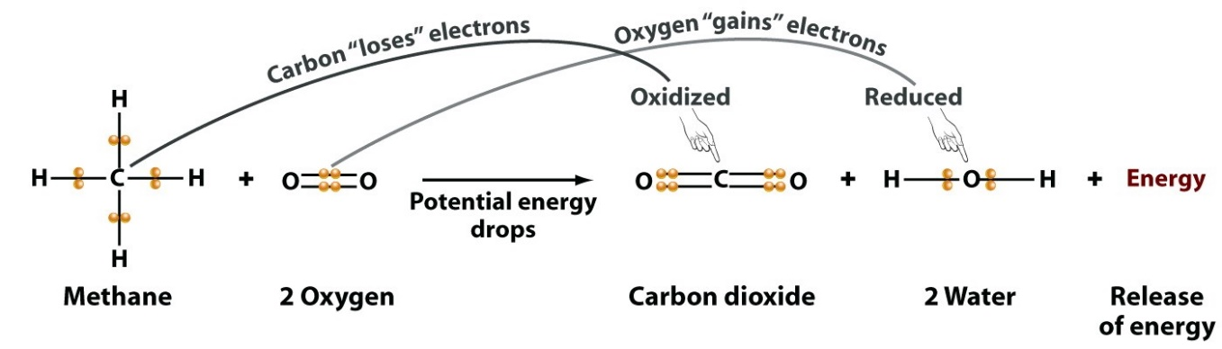

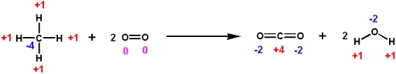

As you can see above, even in molecular equations redox can be identified using oxidation numbers. Carbon increase from **-4** to **+4** therefore **methane is being oxidised**. Oxygen decreases from 0 to -2 therefore the **O2 molecule is being reduced**.

*By using oxidation numbers, we can determine if redox is occurring without drawing molecule structure.*